How to access ESR for GPLEO’s

Step 1 - Go to https://my.esr.nhs.uk Once opened, Click on “Forgotten/Request Username/Password/Unlock Account” as shown below;
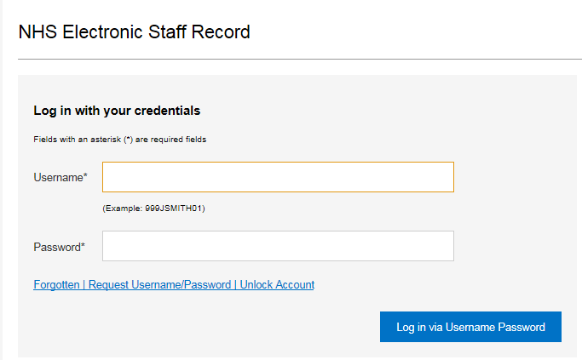

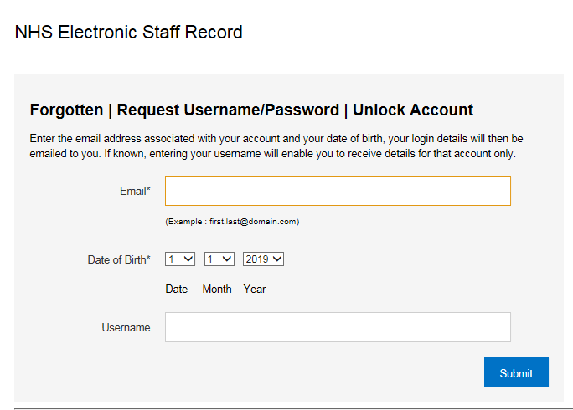
Step 2 - Enter your “Email” address and date of birth in the field highlighted below and click “Submit” please note that this must be the email adress stored for you in ESR.

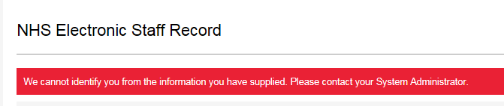
Please Note- If you receive the message below, then this means that the email address entered above is incorrect and not the one that we have recorded for you on ESR. If you do not know what details we have stored for you, then you can contact the GPLEO team at rf.gpleo@nhs.net who can provide this for you.

Step 3 - Once submitted you should receive the confirmation message added below to say an email has been sent, click “Ok”.
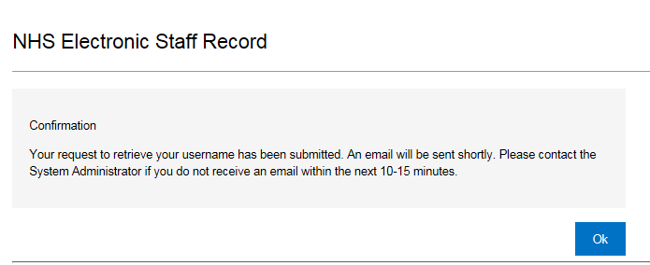
Step 4 - You will then receive an email from Production Workflow, Esr - esr.wfmprod@nhs.net as shown below; please click onto the password reset button link;

Step 5 - You will need to enter the “Username” given in email above and then set up a new password, please find password requirements below:
- Password must be at least 8 characters long
- Password must NOT contain any repeating characters
- Password must contain at least one numeric character
Once you have entered the new password click “Submit”
