

Rota Master User
Registrar Guide



Logging in to the LCD Net Master online portal

Login by visiting: https://lcd.rotamasterweb.co.uk or by selecting the  icon from the bottom of the Local Care Direct Home page. http://www.localcaredirect.org

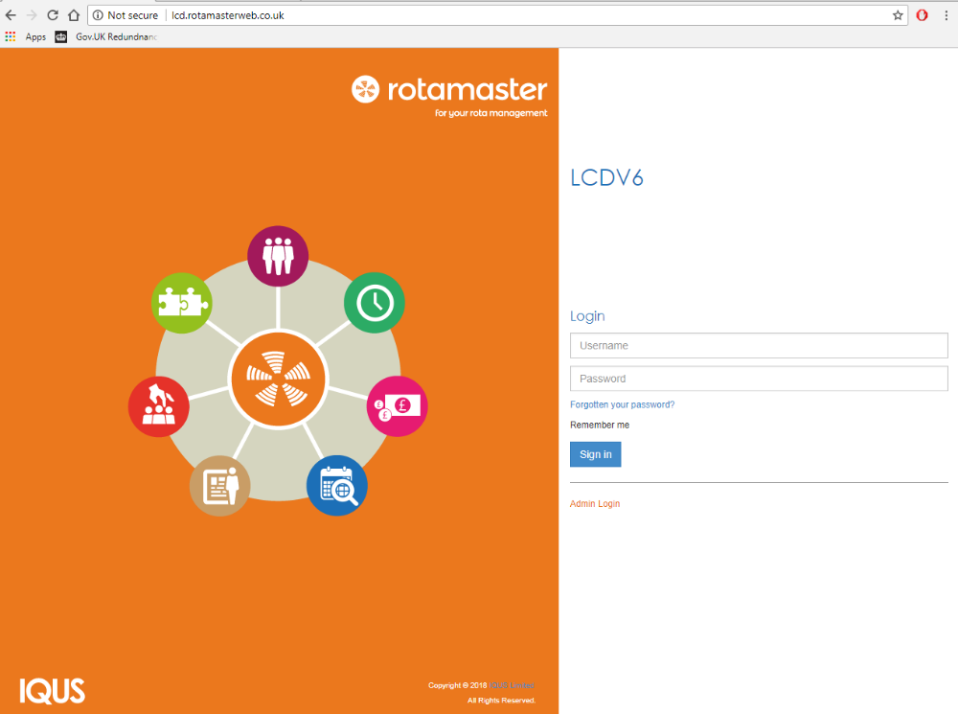

When you get to the website you will see the log on screen.
Enter your personal username and password and log on.

On the Home Screen select “Registrar Shifts” as shown

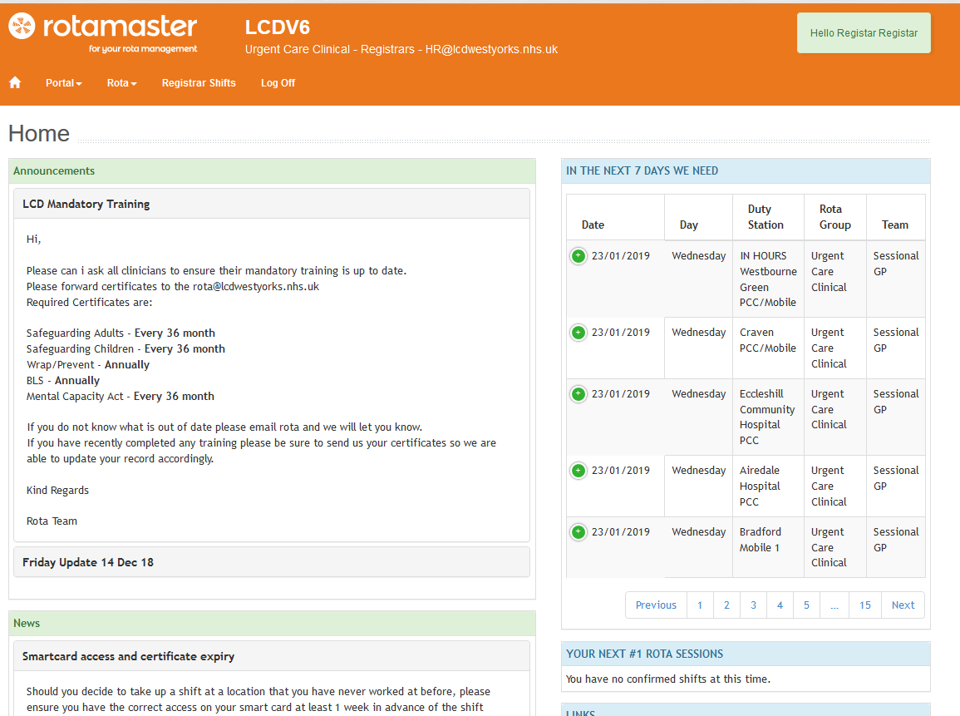

From the booking screen you can select dates, Zones and Duty Stations. To book a session click the green “Book” button on the right.
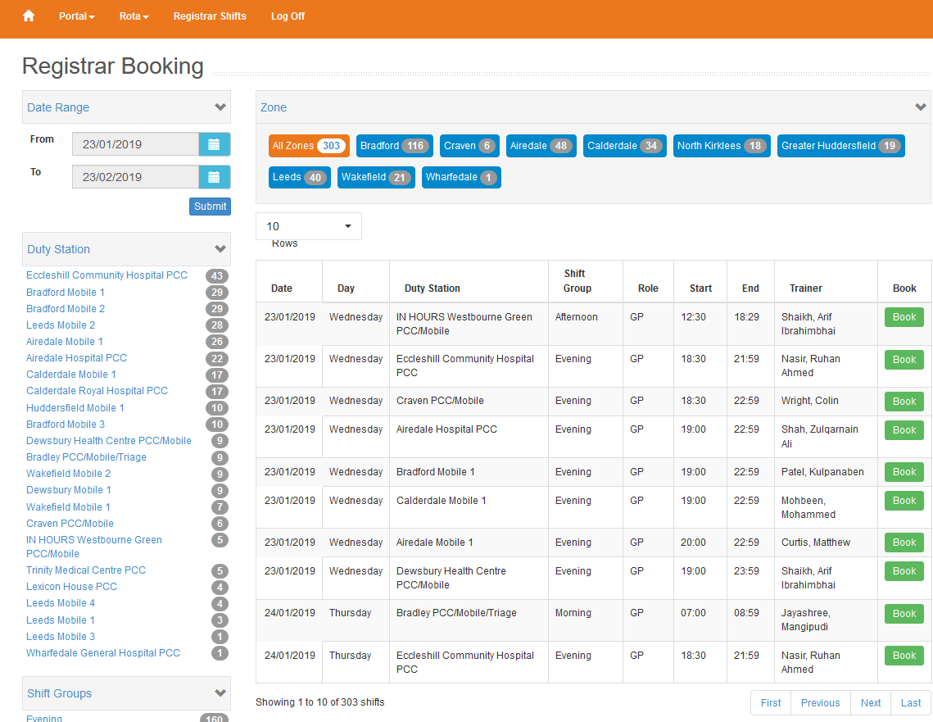

The window shown below will then appear, click Book. You will then be immediately booked into the session and will receive an email to confirm. The GP Trainer will also be notified of your booking.

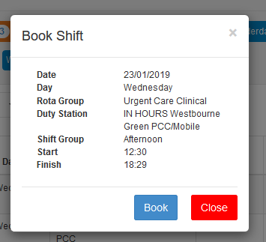
Should you wish to cancel a session please call the rota team on 01484 487287
To view your booked session click “Rota” followed by “My Rota”

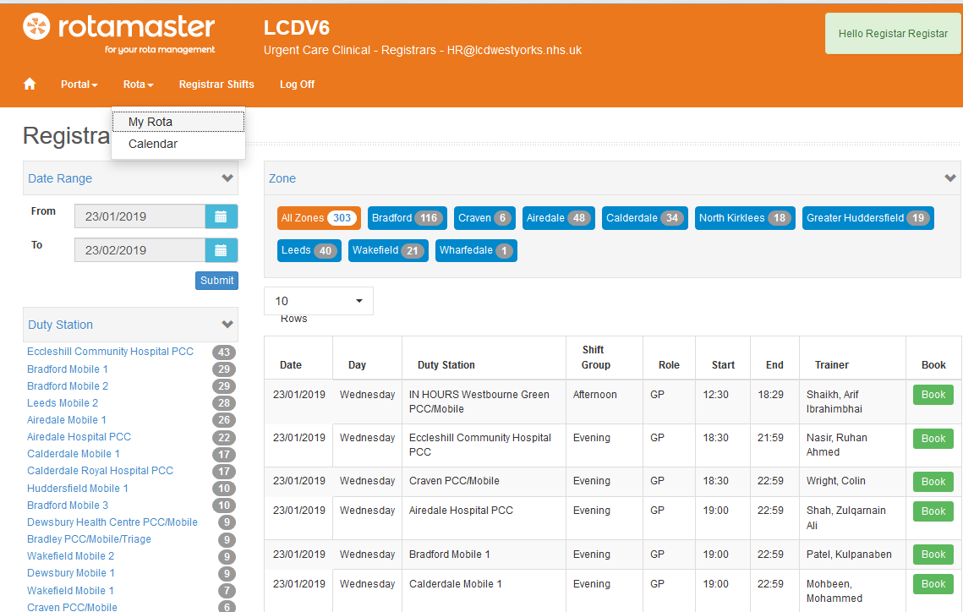

To change your password Select:
Self Service
Profile
Password
Then click change and enter your new password

