How to use Rotamaster

Rotamaster (also known as Netmaster) is managed by the Rota Team based in Warwickshire supported by the Gloucestershire Rota Team. The Gloucestershire.RotaTeam@Careuk.com email allows the two teams to work together.

The introduction page is shown below and includes the telephone number to contact the local Gloucestershire Rota team.

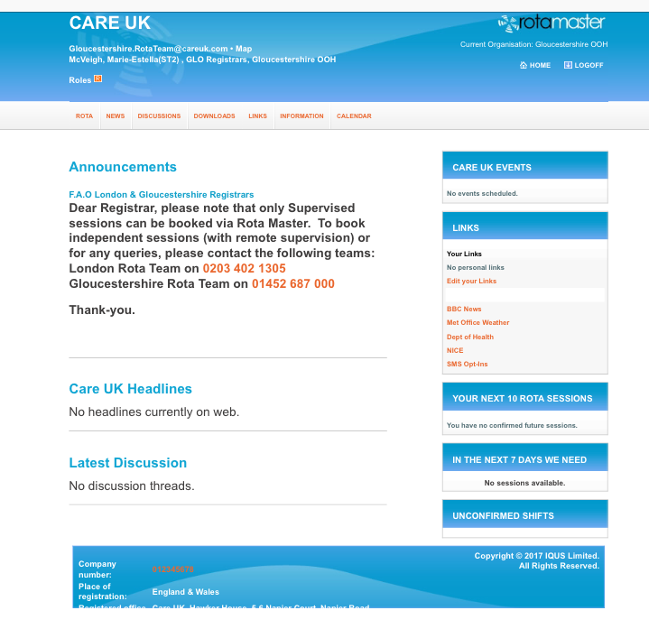

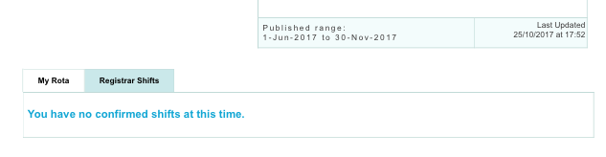

By selecting ‘Rota’ (orange tab top left), and ‘My Rota’ (blue tab bottom right) then shifts registrars have booked into will be shown. The registrar can email ESs by clicking on an orange name. In this case it is not clear where the shift is so the registrar might want to ask the trainer at which base this triage shift is based.
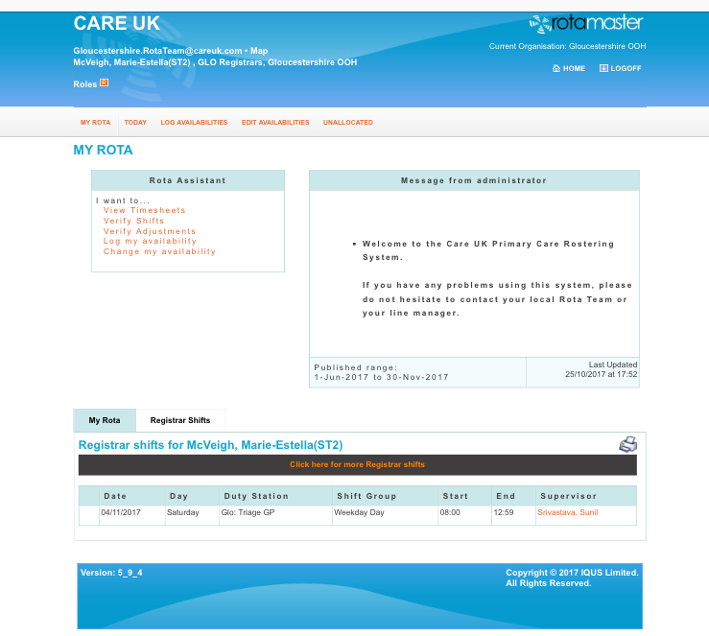

By selecting ‘Registrar shifts’ then ‘click here’ for more Registrar shifts’ (black tab) then all available registrar shifts in Gloucestershire can be viewed. This includes home (mobile) visits.

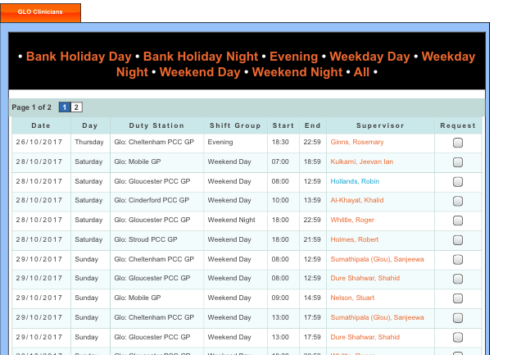

If a trainer is selected an email address is again launched so that the registrar can communicate with the trainer. However this option must not be used to book shifts.

The way to book a shift is to put a tick in a request box. This launches a request for a shift to the two rota teams via the following email Gloucestershire.RotaTeam@Careuk.com. Registrars will be allocated on a first come first served basis. An email confirmation is sent to them.

Gloucestershire.RotaTeam@Careuk.com email should also be used to cancel shifts. Shifts cancelled at short notice, e.g. less than 2 weeks, will also require a reason such as ‘sickness’. If you cancel during the OOH period please speak to the OOH Supervisor on 0330 053 6359 or 07971 450965. Please note that ES are paid a fee for supporting registrars but only if registrar attends.

Once a shift is allocated then this will be shown on the home page as above.

