Presentation Tips for a Learning Session

Overview
- the session is about the participants learning
- the presenter is the facilitator of learning (not just a teacher)
- participation between participants and presenter promotes learning
- PowerPoint may be helpful to support learning, but is not the main focus
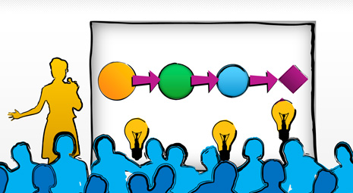
- other resources may be helpful

Overview – Content
- firstly decide what the learners will be learning
- then consider what methods best support this learning
- only then start to design PowerPoint or other resources

Overview – Style
- make the presentation a story with a beginning, middle and end
- engage the audience at the beginning with something interesting, strange, unsettling, etc
- ensure the ending is well-planned, and done in a timely manner
- if necessary (if running out of time), cut some of the central content
- look at the audience, do not turn around and read the slide

Preparing the session
- rehearse the session on your own, checking the sequence and overall time
- practise the art of public speaking, engaging the audience directly; do not rely on PowerPoint
- back up your files in several places, e.g. data stick, email, cloud
- prepare for technology failure, be able to do the presentation without technology

Balance your presentation
- Design – not only function
- Story – not only argument
- Symphony – not only focus
- Play – not only seriousness

Create your presentation in three parts
- Slides the audience will see
- Notes that only you will see
- Handout to be taken away

Handouts and supporting resources
- a handout should be designed as a written document for later use (not just printing of slides)
- include key learning points, not additional supporting narrative

Introduction to NLP – Handout

NLP is the study of how people excel in their field
- neuro: the mind, and how we organise our mental life
- linguistic: language, how we use it, and how it affects us
- programming: our sequences of repetitive behaviour, and how we act with purpose

Main features
- rapport: be curious about how the other person views the world
- goal: know what you want, have a clear idea of your desired outcome
- sensory acuity: be alert, keep your senses open so that you notice details
- behavioural flexibility: keep changing what you do until you get what you want
NLP is concerned with what is useful, rather than what is ‘right’ or ‘true’.

- use the Styles gallery of a Word document, to add emphasis and help communicate the ideas and message of the document

Tips for using PowerPoint well
- ensure the PowerPoint supports what you are saying, and does not just duplicate
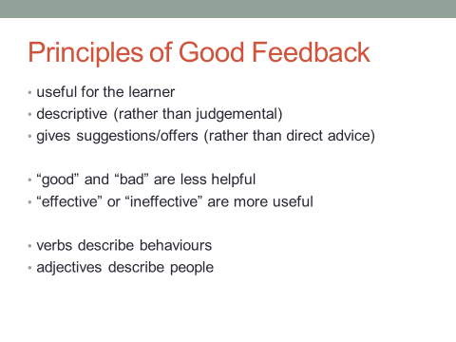
- keep the slides brief with few words and only one point per line
- 7±2 words per line
- 4-8 lines per slide, fewer is usually better
- use diagrams, tables, pictures, video etc. to support the learning point
- use alternatives to simple bullet points, to add interest and variety
- avoid distracting animations, sounds, clip art, etc
- light background with dark text is suitable for normal rooms
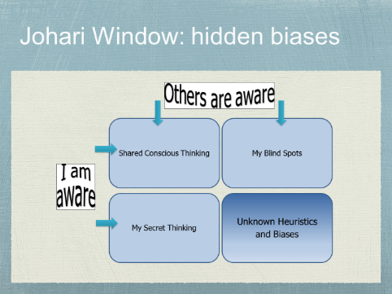
- do not use the print function to generate a so-called handout; nobody reads these
- use bold for a clear and simple form of emphasis and headings
- avoid UPPER CASE, italics or underlining
- 18 point is minimum for slide font
- 36 point is good for titles
- only use sans serif fonts, and be consistent
- align left or right rather than centre, as this is easier to read
- use black slide when wanting to ensure focus is on the presenter
- use black or white slide at the end to avoid closing the presentation

Useful keyboard shortcuts for PowerPoint
- Pressing B turns the screen black, and W turns the screen white. Use one of these at the end or while you take questions. Any key returns you to the show.
- F5 launches a slideshow from an open ﬁle. Shift-F5, launches a show at the current slide
- key in the number of the slide and press ‘return’ to jump to that slide

Make the learners feel good about their learning
When we use positive language, and reinforce the good things learners say and do, the learners feel empowered, which helps them to learn more effectively.
“… people will forget what you said, people will forget what you did, but people will never forget how you made them feel.” Maya Angelou

Additional Tips …

