Quality Improvement Project Handout
You need to complete a QIP in your GP placement in ST1 or ST2. This project should be primary care focused, often with aims of improving patient safety or patient care; but could also focus on wider issues around the environment or staff wellbeing.
It is expected that you do a Quality Improvement Activity (QIA) in the other two years you’re not doing a QIP. Find out more about the difference here: https://www.rcgp.org.uk/gp-training-and-exams/training/workplace-based-assessment-wpba/assessments.aspx

Top Tip!
Remember QIPs are different to Audits:
-Both aim to improve patient care
- AUDITs: are more formal and tend to be done over a longer time frame. You tend to only repeat one cycle after a change has been made,
-QIPs: use the model for improvement as framework which has been shown to test changes successfully and quickly. The PDSA cycle is meant to be repeated, with the aim of approaching a desired goal and the results of each repetition used as starting point for the next cycle. PDSA cycles can be done often e.g. weekly.

Top Tip!
Before you start your QIP, it’s helpful to look at the QIP entry section on Fourteen Fish and the RCGP feedback levels so you know what you are expected to enter into each section of your portfolio entry.
These are the section headings:
Project Title and why it was chosen
Project Aim
Describe what baseline data or information you gathered
How did you plan and test out your changes?
Describe what subsequent data or information you gathered
How have you engaged the team, patients and other stakeholders throughout the project?
Summarise the changes as a result of your work and how these will be maintained.
What have you learnt, and have you got any outstanding learning needs?

- Choose a Project – start with a problem you want to improve
Generate ideas: - any suggestions from the GPs in the practice or practice manager?
- What is your interest? What are you passionate about?
- Have you noticed any areas in your clinical practice which could be improved?
- Ask your supervisor for ideas or guidance
- Ask other trainees or colleagues about QIPs they’ve done in the past

- Gain a better understanding of the problem and gather your baseline data
There are multiple methods to do this through QI tools:https://www.weahsn.net/toolkits-and-resources/quality-improvement-tools-2/more-quality-improvement-tools/

You could try: Root-cause Analysis – the 5 whys?
Process Mapping
Fishbone Analysis
Surveys
These tools enable you to look at different causes of your problem and help you identify areas where you can introduce change. Collect your baseline data from which subsequent measurements will inform the success of your changes.

- Create your SMART Aim:
Specific: don’t make it too big or too broad. Focus on something specific, the more specific the easier it will be to achieve
Measurable: you need to be able to collect measurable data to show your change and evidence your improvement. This can be qualitative or quantitative
Achievable: Pick something that you will be able to get results quickly and do regular data collection for. If you’re overambitious it may become too complicated, and you’ll struggle to finish it or get measurable significant results
Realistic/Relevant: have you chosen something that you will be able to easily introduce and see improvement? Is this going to be something that benefits patients and/or staff?
Time Specific: think about your time frame. QIPs are meant to be done in your 6 month GP placement in ST2. So don’t start too late and do something that can be achieved in this time frame

- Start engaging your stakeholders
This will make up part of your baseline data collection and is a good way to understand the problem and give you ideas about what can be done to bring about improvement. It is important to keep the primary care team up to date; this includes those who will be responsible for ensuring sustained change after you leave.
Think about:
- Who will be affected by any change proposed
- Who will be involved in the implementation of the change
- Who will be responsible for ensuring that any changes will be sustained when you leave.
- Who may you need for advice

Top Tip! It is important to involve and engage your stakeholders early. This will improve the success and sustainability of your project.

- Start your PDSA Cycles:
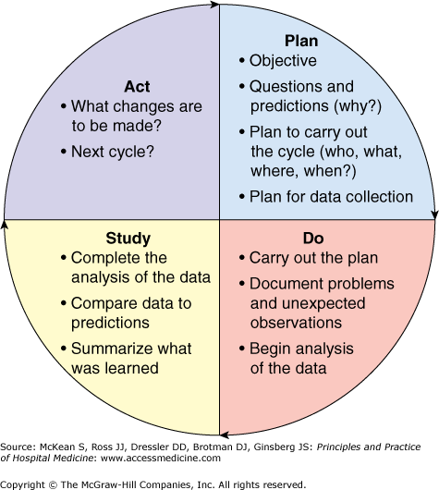
Top Tip!
Driver Diagrams are a useful tool to help you plan your PDSA cycles and come up with multiple change ideas to try.

- Document your Data
With each PDSA Cycle you will need to measure your data to see if there has been improvement.
Measurement can show a number of important pieces of information:
- how well our current process is performing
- whether we have reached an aim
- how much variation is in our data/process
- whether the tests of change have resulted in improvement
- whether a change has been sustained

Remember that data can be quantitative (numerical) or qualitative (descriptive).
Top Tip! Run charts are an excellent way of documenting your data measurements. Follow the link to find out more information: Run Charts - West of England Academic Health Science Network (weahsn.net)

- Summarise and Reflect
At the end of your project, you should summarise the changes made as a result of your project. This could include exploring why the change has been ineffective. Ideally you should present your findings to the team at a practice meeting and reflect on the process and any feedback you receive. An important part of any quality improvement, especially if the changes have improved quality, is ensuring that the process will continue once you leave the job.
Reflection The final process involved reflecting on the process of undertaking a QIP – what have you learnt, what worked well, how did you work with others and what would you do differently in the future.

Resources:
https://qiready.rcgp.org.uk/ - you need to register to access but otherwise is a free and useful resource
https://www.health.org.uk/sites/default/files/QualityImprovementMadeSimple.pdf
https://support.fourteenfish.com/hc/en-gb/articles/360016332798-What-is-a-Quality-Improvement-Project-QIP-
Quality Improvement (QI) tools - West of England Academic Health Science Network (weahsn.net)
https://www.rcgp.org.uk/gp-training-and-exams/training/workplace-based-assessment-wpba/assessments.aspx

