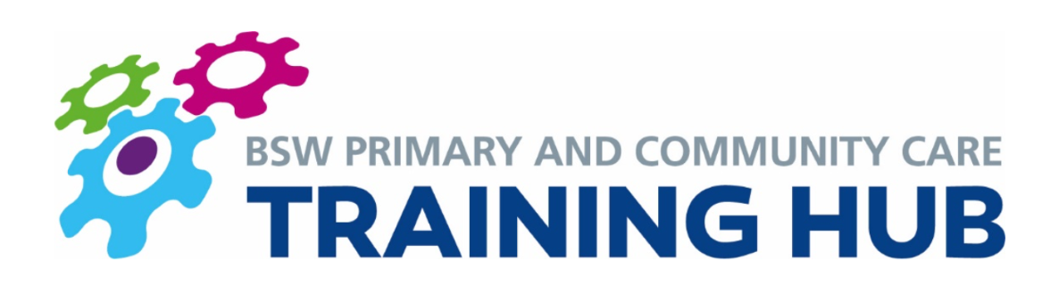
BSW Newly Qualified GP Fellowship Scheme

NHS England released the guidance in August 2020 to confirm that 100% of newly qualified GPs are entitled to take part, to help facilitate their ongoing CPD learning and support them during the transition in becoming an independent practitioner. Each region will run it slightly differently but has to adhere to the same standards. It is open to all those who have recently qualified.

Across BSW the scheme offers the following;

1) Induction / BSW GP Starter Pack
This resource pack aims to help equip GPs with the information they need to transition smoothly into life as a newly qualified GP. The BSW GP starter pack can be found here https://bswtraininghub.nhs.uk/wp-content/uploads/2019/09/BSW-GP-Starter-Pack.pdf
The first session of the First 5 course is also designed to support GPs in the transition from training to employment.

2) Peer-to Peer support
This will take many forms over the 2yrs; an NQG whatsapp group, First 5 peer group, Action Learning Sets…
The First 5 course is run by Simon Philips and Dr Andy Hall who have a wealth of experience in medical education and leadership training. The course will run once a month for 12 months as part of the NQG Fellowship Scheme.

3) Education Trust Membership
This will be delivered through SET (for Swindon GPs), BGPERT (for B&NES and Wilts GPs) and from March 2021, potentially the GP education team of Wessex LMC (for South Wilts GPs). Being embedded in the local GP education system is foundational to any GPs ongoing learning and CPD. Financial pressures often prevent new GPs from accessing these. The NQG scheme offers 2years of paid membership.

4) Mentorship and coaching
The First 5 course mentors will provide support, direction and an objective view on how each GP can develop and progress in their clinical environment. There will also be provision for an experienced mentor to link with each new GP over the course of the 2years who can offer at least six one-hour sessions.

5) Portfolio Work
Each GP is given 1 session per week (or pro-rata equivalent). The First 5 course makes up one of these sessions per month. The other sessions are dedicated time that are given to pursue portfolio working. This can be anything you are interested in. A brief report is expected at the end of each year to describe your work.
Dr Amanda Webb amandawebb@nhs.net (Swindon Clinical Chair of BSW CCG),
Julia Griffiths julia.griffith@nhs.net (BEMS business director) and Gareth Bryant gareth.bryant@wessexlmcs.org.uk (LMC) have agreed to help facilitate some of this. Please get in touch with them directly. I also have a lot of contacts, so if there is anything you would like to develop or gain experience in, please feel free to drop me an email.
NHS England encourage at least 3 months over the 2 years to be used for engaging with your local PCN, to see how they work and help be a part of the team that develops strategies for the local healthcare systems. This could also be a great way for a GP Fellow to lead on a specific project within the PCN if there is an area that they are looking to develop.

6) Primary Care Academy
The Primary Care Academy is a Health Education England initiative to help all fellows across the south west. They provide a series of half day workshops to help develop skills and support newly qualified GPs across the south west regions. ​They also run special interest groups so that fellows can support one another in their portfolio roles. More are in the process of being formed, depending on your interests so please do get in touch with them to put in your preferences. The email address is PrimaryCareAcademy.SW@hee.nhs.uk. The Primary Care Academy and its special interest groups offer an invaluable support and learning network. They are a great way of using your NQG session time.

My hope for the BSW NQG Fellowship Scheme is to offer a comprehensive support and learning network over the 2 years for our new GPs.

Kind Regards,
Jo

Dr Joanne Sinclair
Sessional GP
BSW Training Hub GP
bswtraininghub.nhs.uk

