Teaching attendance over GP training scheme as a LTFT trainee (60%)

As a LTFT trainee you are entitled to attend the same number of teaching sessions as your FT colleagues. A FT ST1/ST2 attends 30 sessions over 12 months (in ST3 it is 40 sessions over 12 months). A 60% LTFT trainee can attend 30 (or 40) sessions over 20 months, or 30 (or 40) sessions in 12 months (followed by a period without teaching). A minimum of 70% attendance is expected for both FT and LTFT trainees during their time as ST1/ST2/ST3.

There is more information here:
http://primarycare.severndeanery.nhs.uk/training/trainees/less-than-full-time-training/show/ltft-expectations-from-a-gp-patch-perspective

During the 3 years of GP Training there is a rolling programme of teaching which repeats. As a LTFT trainee it is possible you may attend the same titled teaching session more than once!

In Swindon we feel it is more beneficial to attend a block of teaching regularly rather than spreading it thinly over a longer period of time. This inevitably results in periods of training when you have no teaching sessions.

These ‘fallow’ periods may occur at the beginning, middle or end of your time as a ST1/ST2/ST3 depending on when in the year you progress to the next stage of training.

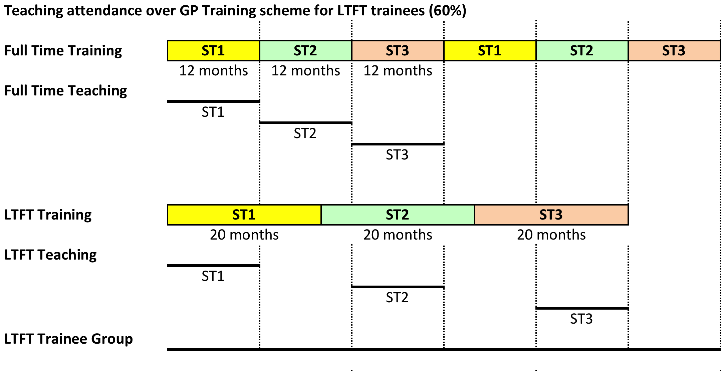

The LTFT group is designed to bridge the gaps in teaching sessions. It offers peer group support and an opportunity to meet with other trainees and TPDs when you are not attending formal teaching sessions. We are keen to ensure that LTFT trainees have ample opportunity to discuss training concerns and challenges and seek advice from their peers in the same way that FT trainees do.

